- Purpose
The purpose of this document is to ensure proper use of Certificates, Licenses and certification marks; Accreditation marks, Certification statements by certified clients of the Certification of MS Agroland Services Pvt. Ltd.
- Scope
This document provided the rules governing the use of all certificates issued and certification marks provided by MS Agroland Services Pvt. Ltd.
- The referenced documents provide the rules governing the use of accreditation body marks (see section 3 below)
- The referenced documents provide the rules governing the use of any statement on product packaging or in accompanying information that the certified client has a certified Organic Standard System
- Responsibility
- Certified clients shall comply with the rules provided in this document.
- MS Agroland Services Pvt. Ltd. Auditors and concerned personnel of certification body are responsible for verifying, at each visit, that certified clients use certificates, licences and certification marks; and accreditation body marks in accordance with the rules provided in this document and reporting infringements to the same, if any.
  - When continuing use of a product certification mark is authorized for placement on a product (or its packaging, or information accompanying it) of a type which has been certified, surveillance shall be established and shall include periodic surveillance of marked products to ensure ongoing validity of the demonstration of fulfilment of product requirements.
  - When continuing use of a product certification mark is authorized for a process or service, surveillance shall be established and shall include periodic surveillance activities to ensure ongoing validity of the demonstration of fulfilment of process or service requirements.
- Process
Section 1: Use of MS Agroland Services Pvt. Ltd. (MS ASPL) certificates and certification marks
  - MS ASPL will provide its certified clients with the relevant certification mark(s).
  - Certified clients may utilize the certification mark in communication media such as the internet, brochures, letter head, envelopes, business cards and certain packaging (see Table 1).
  - When permitted, this mark can be used in conjunction with the relevant accreditation mark (see Section 3 below for references to the additional rules on the use of accreditation body marks).
  - When displayed in conjunction with the accreditation mark(s), MS Agroland Services Pvt. Ltd.’s (Agrocert) mark(s) may only be reproduced in black. When displayed without the accreditation mark(s), MS Agroland Services Pvt. Ltd.’s mark(s) may be reproduced in combined of green and orange of MS Agroland Services Pvt. Ltd, in the predominant colour of the letterhead or printing. The mark may only be reproduced on a clearly contrasting background.
  - If the scope of certification does not include all products and/or services provided by the organization, and/or all locations/facilities of the organization, the material bearing the mark shall not suggest that all products/services/sites/locations of the organization are covered by the scope of certification.
  - The mark(s) cannot be altered or modified. However, it may be resized, provided the proportions of the entire mark are maintained and all features of the mark are clearly distinguishable.
  - The client shall not use the certificate and/or the certification mark(s) provided by MS Agroland Services Pvt. Ltd. in such in a manner that would bring MS Agroland Services Pvt. Ltd. and/or the Accreditation Body or, and/or the Organic Standard System into disrepute and loss of public trust, and shall not make any statement regarding its product certification of MS Agroland Services Pvt. Ltd. may consider to be misleading or unauthorized.
  - Colour photocopies or electronic copies of original “paper” versions of the certificates may be in full colour, and need to be WATERMARKED or otherwise marked as being a COPY of the original.
  - Electronic versions of the certificates provided by MS Agroland Services Pvt. Ltd. and identified as such, can be used by the certified client for publicity/promotional and/or printing purposes without being watermarked or otherwise marked as being a copy of the original. The certificate can be used “as provided” by MS Agroland Services Pvt. Ltd. and cannot be altered or modified.
  - The right to use the certification mark by the organization cannot be assigned to or acquired by any other person, entity, or corporation (including through a change of ownership of the organization) without MS Agroland Services Pvt. Ltd.’s prior written consent.
  - Upon a reduction of the scope of certification, the client shall amend all advertising material referring to its certification to properly reflect the reduced scope.
  - Upon withdrawal or termination of its certification, the client shall discontinue its use of all advertising material that contains a reference to certification, and take actions as required by the certification scheme and any other required measures as directed by MS Agroland Services Pvt. Ltd.
Contractual obligation: Correct use of the certificate, certification mark or accreditation mark is a contractual obligation and will be monitored at surveillance and certificate renewal assessments. Any misuse of the certificate, certification mark by the client may result in suspension or withdrawal of the certification-by- MS Agroland Services Pvt. Ltd. MS Agroland Services Pvt. Ltd.’s considerations with respect to suspension or withdrawal will be as follows:
    - Inadvertent misuse: with this activity, the organization will be required to immediately withdraw the offending materials, or MS Agroland Services Pvt. Ltd. will suspend certification until the misuse is rectified. Repeated inadvertent misuse will not be accepted by MS Agroland Services Pvt. Ltd. and therefore will be cause for withdrawal of certification.
    - Fraud: with an activity considered premeditated on the part of the organization, MS Agroland Services Pvt. Ltd. may withdraw certification and publish notices to that effect in the directory of certified companies.

Section 2: Additional information
  - If you have any questions as to whether your proposed use of the certification marks on an advertisement, brochure or other promotional material is in compliance with these guidelines, please send a sample to MS Agroland Services Pvt. Ltd. for review.
  - For the use of the certification mark on electronic documentation (i.e., websites), the same rules as stated in these guidelines apply.
Section 3: Regulations for grant of license to use certification mark for organic products
The following regulations, which include any modifications and additions thereto, shall apply for grant of a license for use of the Certification Trademark only on the certified products produced, processed, packed, and labelled as per the National Standards for Organic Products. Short Title and Commencement– (1) These regulations may be called the India Organic Certification Trademark Regulations, 2024.
Manner of Applying for License –
- Every application for the grant of a license shall be made to MS ASPL on Form-1. (ASPL-CD-18)
- Every application for a license shall be accompanied by a statement furnishing in detail any scheme of inspection and testing, which the applicant maintains or has been in use or proposes to maintain or to put into use and which is designed to regulate, during the course of manufacture or production, the quality of the product or process for which the license is applied for.
- Every application shall be signed in the case of an individual, by the applicant or, in the case of a firm, by the proprietor, partner or the COO of the firm or by any other person authorized to sign any declaration on behalf of the firm. The name and designation of the person signing the application shall be recorded legibly in the space set apart for the purpose in the application form.
- Every application for a license shall, on receipt by the MSASPL, be numbered in order of priority of the receipt and be acknowledged.
- MSASPL may call for any supplementary information or documentary evidence from any applicant in support of or to substantiate any statement made by him in his application, within such time as may be directed by the MS ASPL and non compliance with such direction may have the effect of the application being summarily rejected by the MSASPL.
- Clients’ Responsibilities
- At all times complies with these regulations as amended from time to time, uses MS ASPL Certification logo in accordance with the conditions defined in the procedure, only in respect of the production and supply of products that are subject to the Certification of Registration from the address stated on the Certificate.
- Maintains and documents operating procedures in accordance with the requirements of the Scheme and makes available copies of all or any part of the documented system as and when MS ASPL require it for reference purposes.
- Does not change the system of production, processing or manufacture under which the Certificate of Registration is issued during the period of its validity unless the holder gives MSASPL a notice in writing of the intention to do so and receives confirmation in writing from MSASPL, that such variations do not render the Certificate invalid.
- Condition of a License
- The Certification Trademark shall be applied in such manner as it may be easily visible as a distinct mark on the products or the packaging or on test certificates relating to articles which cannot be labelled or covered. The Certification Trademark shall be applied to only such types, grades, classes, varieties, sizes of the products for which the license has been granted. The manner, in which the licensee proposes to place or use the Certification Trademark, must be approved by the MSASPL.
- When a Certification Trademark has been specified in respect of an article or process, no person other than the licensee in possession of a valid license shall make any public claim, through any advertisement, sales promotion leaflets, pricelists or the like, that his product conforms to the relevant Certification Trademark or carries the Certification Trademark.
- Every licensee shall institute and maintain, to the satisfaction of the MSASPL, a system of control to keep up the quality of his production or process by means of a scheme of testing and inspection, so as to ensure that the articles or process, in respect of which the Certification Trademark is being used, comply with the relevant norms and procedures of the MSASPL and the NPOP.
- The licensee shall maintain a complete record of the tests and inspection and such other data as specified in the scheme for testing and inspection, to establish to the satisfaction of the MSASPL that the required control of production or process has been and is being satisfactorily maintained. Such records shall, on demand, be made available for inspection to the MSASPL.
- If, at any time,
- there is some difficulty in maintaining the conformity of the product or articles to the specification or if the testing equipment goes out of order, the marking of the product shall be stopped by the licensee, under intimation to the MSASPL. The marking may be resumed as soon as the defects are removed and information regarding such resumption of marking be sent to the MSASPL, immediately thereafter.
- the MSASPL has sufficient evidence that the product carrying the Certification Trademark may not be conforming to designated norms and procedures, the licensee shall be directed to stop the marking of such product. The resumption of marking on the product shall be permitted by the MSASPL after satisfying itself that the licensee has taken necessary actions to remove the deficiencies.
- The decision of the MSASPL for arriving at such decision shall be communicated, in writing by registered post, to the applicant or the licensee, as the case may be.
- An inspection, specially made at the request of an applicant or a licensee, shall be chargeable to the account of the applicant or the licensee. Charges for such special inspection or inspections shall be such as may be decided by the MSASPL.
- When the designated norms and procedures of the MSASPL are withdrawn and not superseded by any other norms and procedures, any license issued in respect thereof shall be deemed to have been cancelled from the date of withdrawal of such designated norms and procedures as stated above and any such license shall be forthwith surrendered to such MSASPL by the licensee. In the case of such cancelled license, a part of the license fee, if paid in advance, proportionate to the unexpired period of the license shall be adjusted against any future fee payable by the licensee or the said part of the license fee can be refunded depending on the decisions of the MSASPL.

- Grant of License –
- MSASPL evaluation is satisfied that the applicant or Licensee having regard to requisite skill, resources, production, processing previous performance & antecedents relevant to the issuance of the license is fit to use the Certification Mark, MSASPL shall grant a license in Form 2 authorizing the use of the certification mark in respect of the product or class of products manufactured by the applicant or licensee in respect of the process employed in any production, manufacture or work, subject to such terms and conditions as specified in these regulations. MS ASPL shall intimate the applicant about grant of license.
- The Applicant shall be entitled to use the Certification Mark and restrict his use thereof to goods or services, which will meet the norms and standard specification of the products. The Certification Mark may be affixed to the products and / or used on packaging or promotional material or in the context of advertising activities after prior permission obtained from MS ASPL.
- In the event of a withdrawal of the right to use the aforesaid mark the certificate or the license shall be returned to the MS ASPL. The right to use the Certification mark expires at the same time without giving rise to any indemnification claim against MS ASPL
- The applicant is entitled to the aforesaid Mark but shall be answerable for the safety of their products themselves. They shall furnish proof of holding sufficient product liability insurance in respect thereof, if asked required by the MS ASPL. No liability whatsoever will be accepted by MS ASPL in case of failure of the above clause.
- On receipt of an application for a license and before granting a license, the MSASPL may:
- Require evidence to be produced that the product or process in respect of which a license has been applied for conforms to the standards and specifications set out in the NPOP and the NSOP;
- Require evidence to be produced that the applicant has in operation a scheme of routine inspection and testing, which will adequately ensure that all marked products or process shall conform to the standards and specifications set out in the NPOP and the NSOP;
- Require all reasonable facilities to be provided to an Inspector of the MSASPL to inspect the farms, processing units, office, workshop, testing laboratories or godowns and any other premises of the applicant and to draw and test a sample or samples for the purpose of verifying the evidence produced by the applicant under clause (a) or clause (b) or both;
- For the purpose of clause (a), direct the applicant to submit samples to such testing authority as MSASPL may consider appropriate. The expenses for testing shall be borne by the applicant; and
- On the basis of any report received under clause (c) or clause (d) or both, the MSASPL may, as deemed fit, require the applicant to carry out such alterations in, or in addition to, the process of manufacture or production in use by the applicant
- Suspension of Use of Logo
- Any license granted by MS ASPL may be suspended or cancelled by it, if it is satisfied:- that the products marked with the certification mark under a license do not comply with the related norms and procedures of the MS ASPL; or that the licensee or applicant had used the Mark in respect of a process which does not come up to the related directions and specification of MS ASPL; or that the licensee or applicant failed to provide reasonable facilities to the MS ASPL enable them to discharge the duties imposed on them; or that the licensee or applicant has failed to comply with any of the terms and conditions of the license.
- Before MS ASPL suspends or cancels any license, it shall give the licensee not less than 14 notice of its intention to suspend or cancel the license. On the receipt of such notice, the licensee may submit an explanation on his behalf to MS ASPL within fivteen days from the receipt of the notice. If a satisfactory explanation is submitted, MS ASPL may consider the explanation and give a hearing to the licensee within 14 days from the date of receipt of such explanation or before the expiry of the notice whichever is longer.
- If no explanation is submitted, MSASPL may, on the expiry of period of the notice, suspend or cancel the license by addressing a written note within 14 days of the expiry of the period
- Where a license has been suspended or cancelled, the licensee shall discontinue forthwith the use of the certification mark not withstanding the pendency, of any appeal before the MSASPL and if there be, with the licensee or his agents, any articles in stock which have been improperly marked, the licensee or his agents, as the case may be, shall take necessary steps to get the certification mark on such articles either removed, cancelled, defaced or erased.
- When a license has been suspended or cancelled, the MSASPL grant publish such a suspension or cancellation in a manner as found appropriate by MSASPL.
- Specifications
More details are available in the Chapter 7 standard of NPOP

    - The India Organic Logo under National Programme for Organic Production (NPOP) is given below

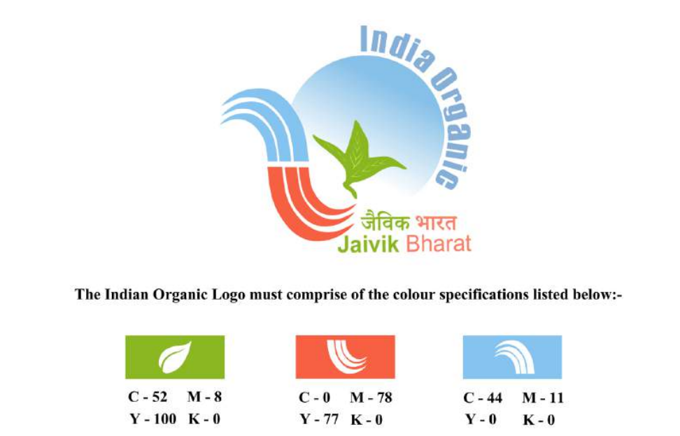

    - The India Organic Logo under NPOP may also be used in black and white as given below, as an exception at the primary production level only and under circumstances where it is not feasible to apply it in colour:
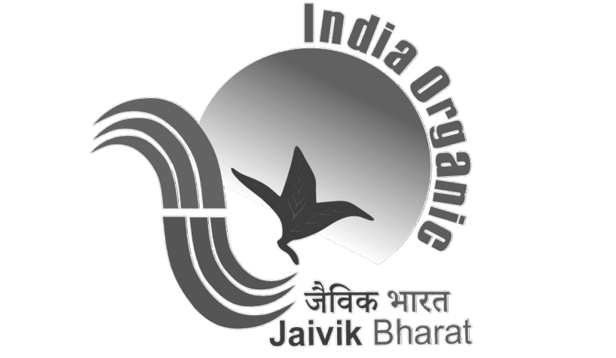

    - For use of India Organic Logo in black and white, prior written permission will be sought from the MS ASPL stating clearly the justification for such request.
    - The India Organic Logo in Black and White shall be used only at the primary production level and for those products and scope for which permission has been granted in writing.
- Surveillance and regular review-
- The grant of license shall be followed by surveillance visits wherever necessary. The frequency and extent of visits shall be determined by MSASPL.
- The surveillance visits may be without notice to the licensee to ensure that the systems and procedures already assessed are being maintained.
- The special reassessment visit shall be necessary where a licensee fails to observe the conditions of the license or where there have been significant changes in the organization of the licensee. The licensee shall be liable for the costs of such special visits.
- Obligations of the licensee-
A licensee on grant of a license to use of the certification mark shall:
- at all times comply with the requirements of the license as set out therein and comply with these regulations or any amendments here to.
- Only claim that he is holding a license in respect of the capability which is the subject of the license and which relates to the products or processes in accordance with the license requirements.
- not use the license in any manner to which MSASPL may object and shall not make any statement concerning the authority of the licensee’s use of the license which in the opinion of the MSASPL be misleading, submit to MSASPL for approval of the form in which he proposes to use his license or proposes to make references to the license.
- upon suspension or termination of the license, however determined, discontinue its use forthwith and withdraw all promotional and advertising matter which contains any reference thereto,

- Permit access to the inspector of MSASPL for purposes of assessment, audit or surveillance. The licensee shall give full details of all actions taken in response to field problems arising from allegations of defects in products or processes covered in the license and allow the inspector of the MSASPL access to all relevant records and documents for the purpose of verifying such details.
- Be required to produce evidence of continuing operations for the products or processes covered by the license. Licensee shall notify to the MSASPL in writing of discontinuance in such operations exceeding three months. Discontinuance of a license in excess of six months or more may lead to cancellation of license. In such cases, application shall be lodged with the MSASPL and an assessment visit will be necessary prior to grant of a new license,
- Pay all financial dues to MSASPL in the manner prescribed by it, even for the period of discontinuance or suspension of license.
- Misuse of license-
    - The licensee shall be deemed to have misused the license, if he does not cease to display or otherwise use the license for use of the certification mark immediately after :
        - Surrender, suspension, withdrawal or termination of Accreditation under NPOP.
        - Surrend, suspension or cancellation of license,
        - The licensee has failed to implement changes as advised by MS ASPL.
    - In case of misuse of license for use of India Organic Certification Mark, the licensee shall be liable to be prosecuted as per applicable law.
- Surrender of the license:
- A license may be surrendered by the licensee at any time in writing to the MSASPL.
- In the case of surrender, the licensee shall return the licence with all the related documents to the MSASPL.
- The licensee has failed to implement changes as advised by the Accredited Certification Body.
- Label Assessment
- The certified client must use approved labels on the certified products hence label approval must be sought from the MS ASPL before using the labels.
- After receipt of the label for approval, Certification Manager must assess it using Label
- Assessment Form.
- Label for all certified products needs to be assessed separately.
- Label can be approved only if all applicable criteria mentioned on assessment form are in
- compliance. If label cannot be approved then Certification Manager must mention the missing or incorrect information and ask the client to make relevant corrections.
- The label received after corrections must be assessed using new assessment form.
- The label approval will remain valid until the client make any changes in the label provided that
- the client is having approval from MS ASPL for use of India Organic
- logo (if logo is used on the label).
- The copy of Label assessment form along with Approved / Not approved label must be provided
- to the client and also filed in the client file.
Undertaking
Prior to the grant of license, the applicant shall sign an undertaking to the effect that he will make no claim, direct or implied, that the license to be granted relates to any products or processes other than those that will be set out in the license

Revocation of License:License to use the Certification Trademark may be revoked if the licensee:
- Challenges the validity of the Certification Trademark; or
- Challenges the Ministry of Commerce & Industry as the sole, absolute,
- and exclusive owner of all right, title, and interest in the Certification Trademark, and the goodwill associated therewith; or
- Takes any action, which would impair the rights of Ministry of Commerce & Industry in and to the Certification Trademark or the goodwill associated therewith.

Records :
Record Name | Responsibility | Location | Period
ASPL-CD-ANX-10- Logo uses guidelines | Quality Manager/ Certification Manager/ Client | MS Agroland Services Pvt. Ltd. | 05 years
ASPL- ICD-13- Certification Agreement | Quality Manager/ Certification Manager/ Client | MS Agroland Services Pvt. Ltd. | 05 years
ASPL- AD-07India organic logo Label Assessment Form | Quality Manager/ Certification Manager/ Client | MS Agroland Services Pvt. Ltd. | 05 years
Form 1 | Quality Manager/ Certification Manager/ Client | MS Agroland Services Pvt. Ltd. | 05 years
Form 2 | Quality Manager/ Certification Manager/ Client | MS Agroland Services Pvt. Ltd. | 05 years
Form3 | Quality Manager/ Certification Manager/ Client | MS Agroland Services Pvt. Ltd. | 05 years

