**Purpose**

The purpose of this document is to ensure proper use of IOAS Accreditation Mark by MS Agroland Services Pvt. Ltd. (MS ASPL) and it’s certified clients.

**Scope**

The referenced documents provide the rules governing the use of Accreditation Body mark

**Responsibility**

* Certified clients shall comply with the directives provided in this document.
* MS Agroland Services Pvt. Ltd. (MS ASPL) are responsible for verifying, at each visit, that certified clients use the Accreditation mark as per the directives provided in this document.
* The Certification Manager/ COO is responsible for the enforcement of the directives provided in this document

**Procedure**

**B.1 IOAS acronym, logo, accreditation claims and the IOAS accreditation symbol**

B.1.1 Claims of being accredited or in some way approved by or linked with IOAS might occur through use of the IOAS acronym, logo, written or verbal statements or through use of the IOAS accreditation symbol.

B.1.2 The IOAS acronym is that indicated here, is legally registered and protected and is only for use by IOAS.

B.1.3 The IOAS logo is that indicated here. It shall not be used by any other entity unless specific permission has been given e.g., promotional, sponsorship or joint events with others.

B.1.4 Accreditation claims can be made by accredited MS ASPL in the form of statements. The format and context of such statements is regulated below in section B4.

B1.5 The IOAS accreditation symbol is that indicated in section B.4 below and can be used by MS ASPL that have received an IOAS accreditation certificate.

**B.2 Who can make claims**

B.2.1 Claims of being accredited by IOAS through statements or by use of the IOAS accreditation symbol shall only be made by MS ASPL that have been issued an IOAS accreditation certificate. The following entities shall not make any such claim.

1. a) MS ASPL that have applied to IOAS but have not yet been issued an accreditation certificate by IOAS;
2. b) MS ASPL that have been assessed by IOAS but have not been issued an accreditation certificate by IOAS. This applies to MS ASPL in schemes where another entity makes the accreditation decision or where the MS ASPL has requested assessment but not accreditation;
3. c) MS ASPL, inspection bodies or other entities that are subcontracted by an IOAS accredited MS ASPL;
4. d) Any other entities including certified operators or non-certified operators.

**B.3 Obligatory and optional use by accredited MS ASPL**

B.3.1 In order that interested parties are correctly informed of the MS ASPL accreditation status, MS ASPL that have received an IOAS accreditation certificate are required to declare their accredited status:

1. a) On scope certificates issued to operators under the IOAS accredited scheme;
2. b) On their web sites.
3. B.3.2 In both cases, the MS ASPL may choose between making written statements or using the IOAS accreditation symbol following the requirements in B4.
4. B.3.3 Written claims or use of the accreditation symbol are optional for accredited MS ASPL on promotional materials, MS ASPL documents, letterheads and business cards.
5. B.3.4 Accreditation claims of whatever kind and location shall not be misleading about the scope of the accreditation (see B4).
6. **B.4 Format of MS ASPL claims on operator scope certificates and web sites and other materials**
7. B.4.1 The IOAS accreditation symbol is in the formats which appears below:

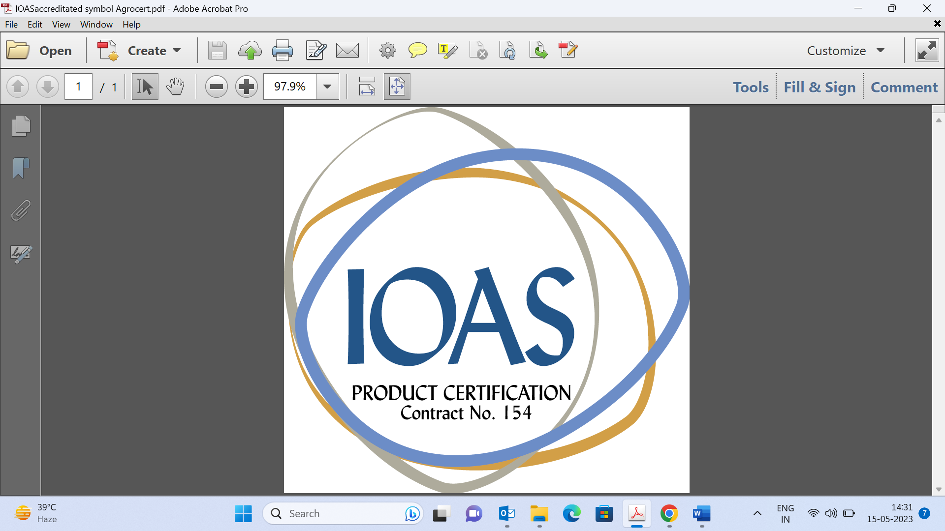

B.4.2 The symbol is based on the IOAS company logo with the addition of the words ‘Product Certification’ which denotes the activity to which the accreditation refers along with the contract number of the certification body allocated by the IOAS.

B.4.3 Each certification body will, on accreditation, be issued an electronic version of their unique symbol indicating the correct contract number.

B.4.4 This symbol must be used by all accredited MS ASPL without alteration unless the text option stated at B.4.9 and 4.10 is preferred.

B.4.5 The IOAS accreditation symbol may not be used by MS ASPL under schemes in which the IOAS does not make the accreditation decision.

B.4.6 In all cases the symbol may be used in its actual colour or in black and white and must keep its proportions. No other colour variations are accepted.

B.4.7 IOAS symbol shall only be used in conjunction with the logo of the MS ASPL and shall not be of larger size.

B.4.8 The size of the accreditation symbol shall not be so small that the contract number is illegible.

B.4.9 If the MS ASPL prefers not to use the accreditation symbol, statements on certificates are permitted such as ‘This certificate is issued within the scope of the accreditation for product certification issued by IOAS. Registration number: (MS ASPL contract number with IOAS)’

B.4.10 Statements, rather than the IOAS accreditation symbol, may also be used on web sites. These statements should take the format:

‘MS ASPL name is accredited by IOAS for the scope of product certification. Registration number: (MS ASPL contract number with IOAS). Please refer to www.ioas.org/accreditation/accredited-bodies/ for current information’.

B.4.11 If MS ASPL promotional material refers to any activity not covered by the accreditation scope, mention of accreditation shall be accompanied by limiting clauses as specified in B.4.9 and 4.10 above. The scope of accreditation is stated in the IOAS web site certification body list.

B.4.12 Promotional material that specifically mentions categories of activity that are not covered by the accreditation scope shall not mention the accreditation status without specifically referring to the accreditation scope. Thus, a brochure that for example mentions the certification of non-scope activities shall not include on the brochure the accreditation status without specifying the activities that the accreditation scope covers. ‘Certifier X is accredited for ........ etc’.

B.4.13 The same rule applies to promotional material that mentions other certification schemes operated by the MS ASPL that are not covered by the accreditation scope. Thus, a brochure that mentions (for example) that the MS ASPL operates a sustainable forestry certification scheme which is outside of the scope of accreditation shall not mention the IOAS accreditation status without referring to the scheme that is covered by the accreditation scope. In such a case the statement that ‘Certifier X is accredited’ is not permitted without clarifying language of the scope of the accreditation.

B.4.14 Materials that do not mention specific activities or schemes such as letterheads or business cards may refer to the accreditation status without limiting clauses if there are no schemes outside of the accreditation scope. If the Certification Body does operate other certification schemes the accreditation reference must specify the applicable scheme.

**B.5 References to accreditation by operators**

B.5.1 Operators may make statements regarding the accreditation status of their Certification Body in brochures and other promotional material as long as IOAS and any scheme owner rules are observed.

B.5.2 Accreditation statements shall clearly refer to the Certification Body and not any product. Thus, statements such as ‘this product is certified by Certifier X, an IOAS accredited Certification Body’ are permitted if in line with more specific scheme owner rules. A statement that states e.g. ‘’Scheme name’ accredited’ on the promotional material is not permitted.

B.5.3 If the operator promotional material refers solely to products not covered by the accreditation scope no reference to accreditation shall be made.

B.5.4 If the promotional material refers to products, only some of which are covered by the accreditation scope, then reference to the accreditation shall state the categories of accreditation covered by the accreditation scope.

**B.6 Accreditation or other misleading or confusing claims by other parties**

B.6.1 Any reference to IOAS accreditation or use of IOAS logo or symbol by a not accredited third party is prohibited and IOAS will take corresponding actions.

B.6.2 IOAS shall monitor and follow up leads on any claims or use of the IOAS logo and acronym that may cause confusion in the market.

**C Procedures**

**C.1 Surveillance and dealing with incorrect or unauthorised claims**

C.1.1 The correct format and use of any accreditation claims and/or the accreditation symbol by clients of IOAS as described above shall be verified as part of IOAS assessment and surveillance measures.

C.1.2 Non-conformities shall be issued, and MS ASPL corrective actions taken to resolve such issues in line with the normal assessment process.

C.1.3 Incorrect or unauthorised use by other parties may come to IOAS’ notice through complaints, leads provided by other sources and by active web surveillance.

C.1.4 Any potential misuse should be brought to the attention of the Quality Manager (QM). All notifications of potential misuse shall normally be made in writing or electronically containing any evidence (labels, brochures, etc.) to support the alleged misuse.

**C.2 Investigation of misuse of accreditation status or IOAS logo/name use**

C.2.1 Upon receipt of an alleged misuse of accreditation status or logo use, IOAS QM shall:

* 1. a) Clarify the following information (if applicable): • name, address and telephone number of the party making the claim;
  2. • name of party alleged to misuse of accreditation status;
  3. • extent, location and/or circumstances where alleged misuse occurred;
  4. • date and time when alleged misuse occurred;
  5. • any witnesses and/or evidence to support the alleged misuse; and,
  6. • any other information deemed important.
  7. b) (If applicable) gather additional evidence from other sources to substantiate the claim.
  8. c) Within 3 weeks of receipt of the allegation notify the alleged party of the potential misuse and invite a response using document FR0535i. This shall require a response within 2 weeks.

C.2.2 Following the response to notification letter the IOAS QM shall assess whether a satisfactory resolution of the misuse is imminent or may require further action.

C.2.3 If the resolution is satisfactory and imminent, QM shall, within 3 weeks of receipt of response to the notification letter, confirm the mutual understanding of the resolution by sending document FR0535ii which shall advise of possible action if the resolution is not adhered to.

C.2.4 If a timely and acceptable resolution is unlikely or if there is no response, QM shall, within 3 weeks of receipt of response (or due date) to the notification letter, invite a (further) response within 2 weeks by sending document FR0535iii which shall advise of possible action if there is either an unsatisfactory or no reply.

C.2.5 If this action results in an unsatisfactory or no reply the QM shall consult with the ED and ultimately the IOAS Board of Directors who will consider the need for legal action. This shall also apply to the use of the IOAS acronym and similar graphical representations by any entity. In all cases legal support may be required to determine appropriate actions and the likelihood of success.

C.2.6 When appropriate, IOAS shall post an advice on the IOAS web site to indicate that an entity has made an incorrect or unauthorised reference to IOAS or claim.

C.2.7 Complete records of such correspondence shall be maintained.

**Reference:**

PL0515 Policy on Accreditation Claims and Use of the IOAS Accreditation Symbol